**Smart Methods Auto Control Panel**

**Auto Control Panel Web Page**

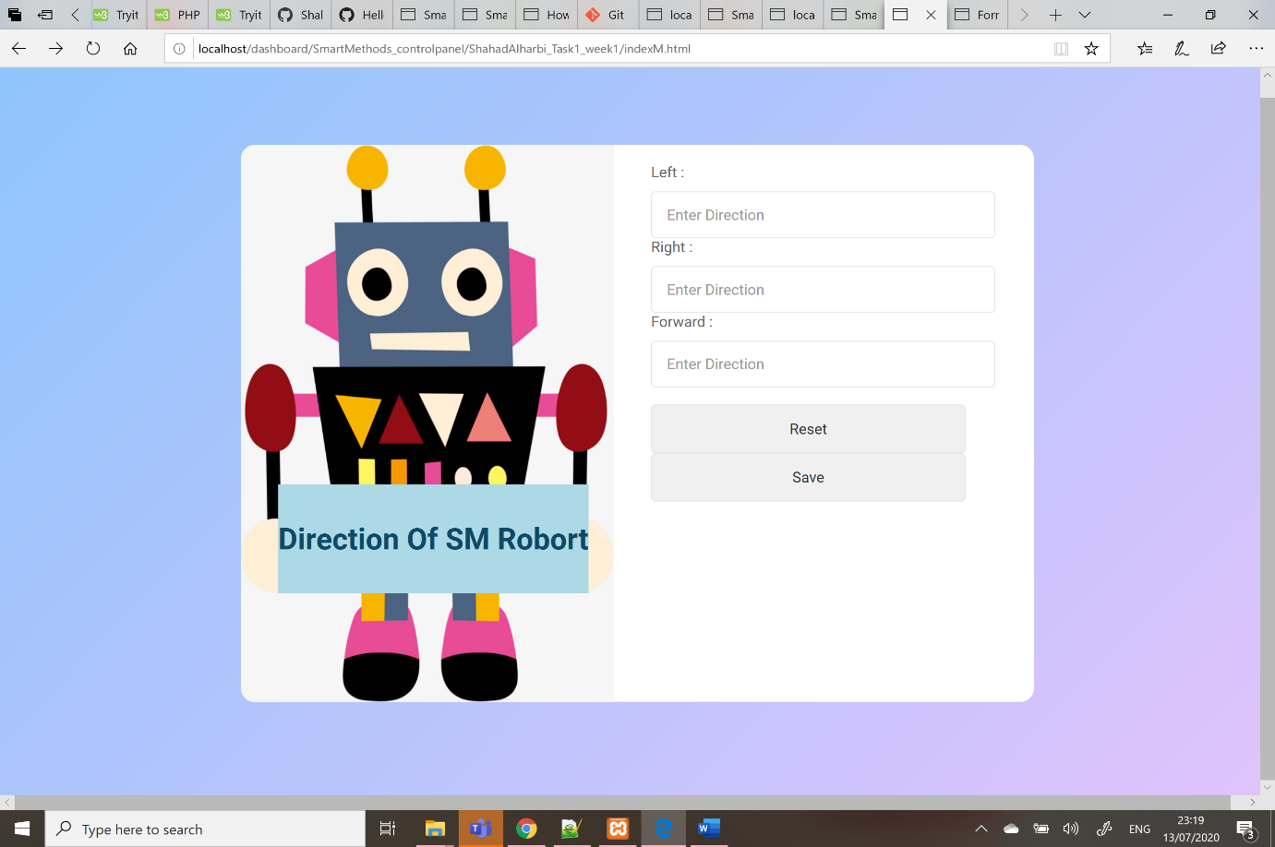

**Auto Control Panel Web Page Response**

**Direction Database Records**

